**The pH scale**

In chemistry, pH is a scale used to specify how [acidic](https://en.wikipedia.org/wiki/Acidic) or [basic](https://en.wikipedia.org/wiki/Base_(chemistry)) a [water-based solution](https://en.wikipedia.org/wiki/Aqueous_solution) is. Acidic solutions have a lower pH, while basic solutions have a higher pH. At room temperature (25 °C), [pure water](https://en.wikipedia.org/wiki/Pure_water) is neither acidic nor basic and has a pH of 7.

The pH scale is [logarithmic](https://en.wikipedia.org/wiki/Logarithmic_scale) scale based on the [molar concentration](https://en.wikipedia.org/wiki/Molar_concentration) (mol L-1) of [hydrogen ions](https://en.wikipedia.org/wiki/Hydrogen_ion) in a solution. The pH value can be less than 0 for very strong acids, or greater than 14 for very strong bases.

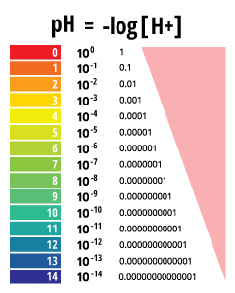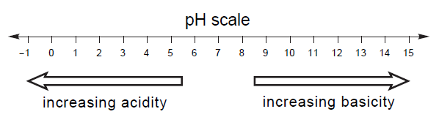

**Calculating pH of an aqueous solution from [H+]**

The pH of an aqueous solution can be calculated using the expression:

pH = - log [H+]

**Example:**  Find the pH of a solution with a [H+] of 0.0025 mol L-1.

pH =  - log [H+] = - log (0.0025) = - ( - 2.60) = 2.60

**Practice Examples:**

1. Find the pH of a solution with a [H+] of 0.037 mol L-1. (answer 1.43)
2. Find the pH of a solution with a [H+] of 0.437 mol L-1 (answer 0.360)
3. Find the pH of a solution with a [H+] of 1.35 x 10-12 mol L-1 (answer 11.870)

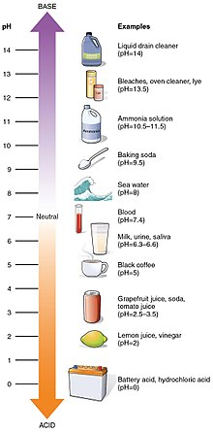

**pH of Common Household Liquids**

**What is a Logarithm? (Extension)**

In its simplest form, a logarithm answers the question:

How many of one number do we multiply to get another number?

Example: How many 10s do we multiply to get 1000?

Answer: 10 × 10 × 10 = 1000, so we had to multiply 3 of the 10s to get 1000

So the logarithm is 3

**How to Write it**

We write "the number of 10s we need to multiply to get 1000 is 3" as:

log10(1000) = 3

**Another Example**

How many times do we multiply 2 to get 8

2 x 2 x 2 = 8 the answer is 3 times

This can be written as log28 = 3

